Referee Bias in the NBA - The “Star Player Effect”

“You can’t get too close to Michael [Jordan] or it’s a foul” – Magic Johnson, 1992

# Background

The NBA has always been a business driven by the presence of its biggest individual stars. There are many reasons for this, whether it be because of the relatively small rosters put forth in basketball, or the increased focus on player personalities, or players themselves being more enmeshed in American popular culture. Nevertheless, the deference the league shows towards its most important (and revenue-generating) players is certainly very strong.

This deference shown off-court naturally raises another question: star bias on the court. Many fans of the NBA have often alleged that star players receive preferential treatment on the court from referees and officials in game-time situations. The analysis of this favoritism will be the primary focus of my paper.

NBA referees primarily affect the course of games by awarding (or neglecting to award) fouls and violations. Violations are instances when a player mishandles the ball or makes an illegal move. They are usually punished with a change of possession of the ball. Fouls typically involve illegal contact, and in most cases are punished with either a loss of possession or free throws. In the case where a player commits six or more fouls, they are suspended for the rest of the game (ie. Fouled out).

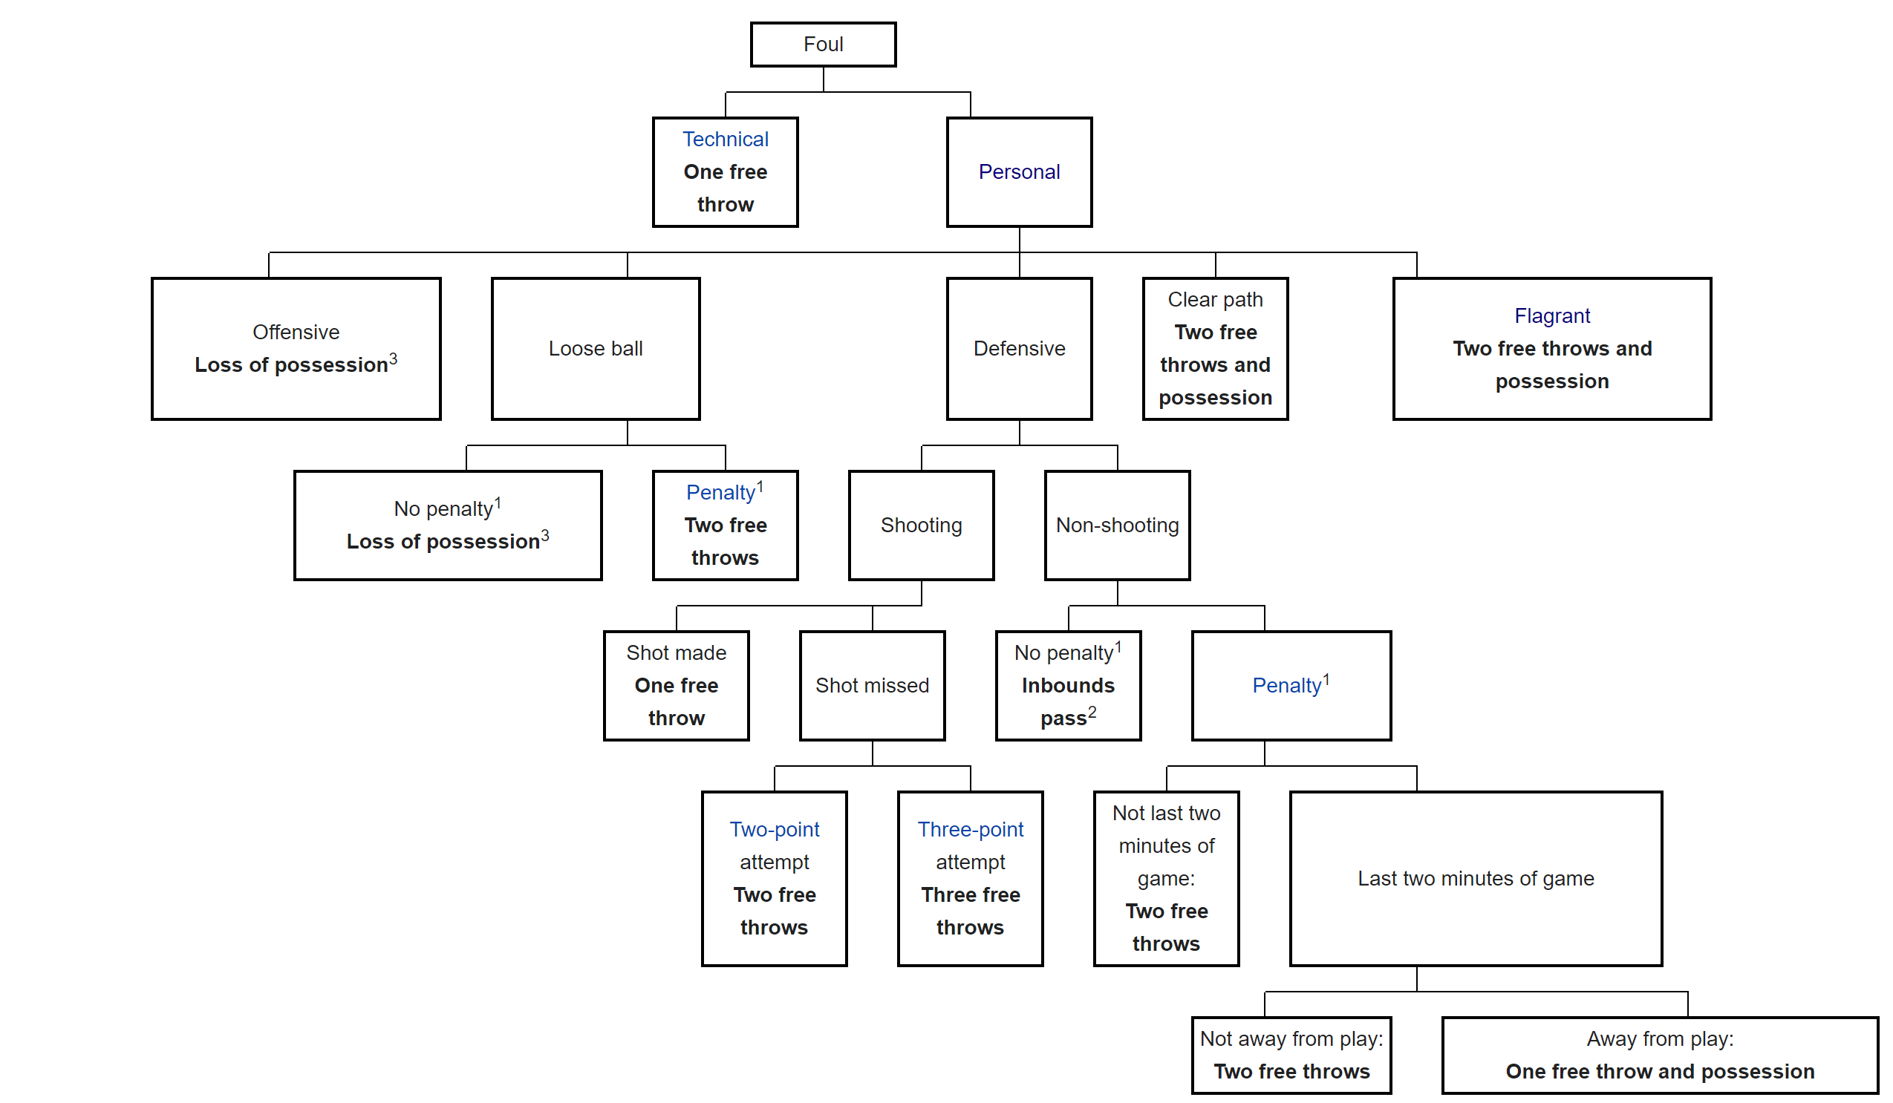

Source: Wikipedia. I’ll come up with a better graph with more citations for the final paper.

In reality, the decision to award and reject fouls is often times highly subjective. In many instances determining what constitutes as illegal contact is difficult and subjective. Referees are forced to make split-second decisions that may in close situations impact the course of the game. Many players are often very vocal about fouls awarded during game-time. This is not helped by the fact that many players have made drawing fouls from other players a dedicated part of their strategy. This means that the decision to award and not to award fouls has the potential to be subject to bias.

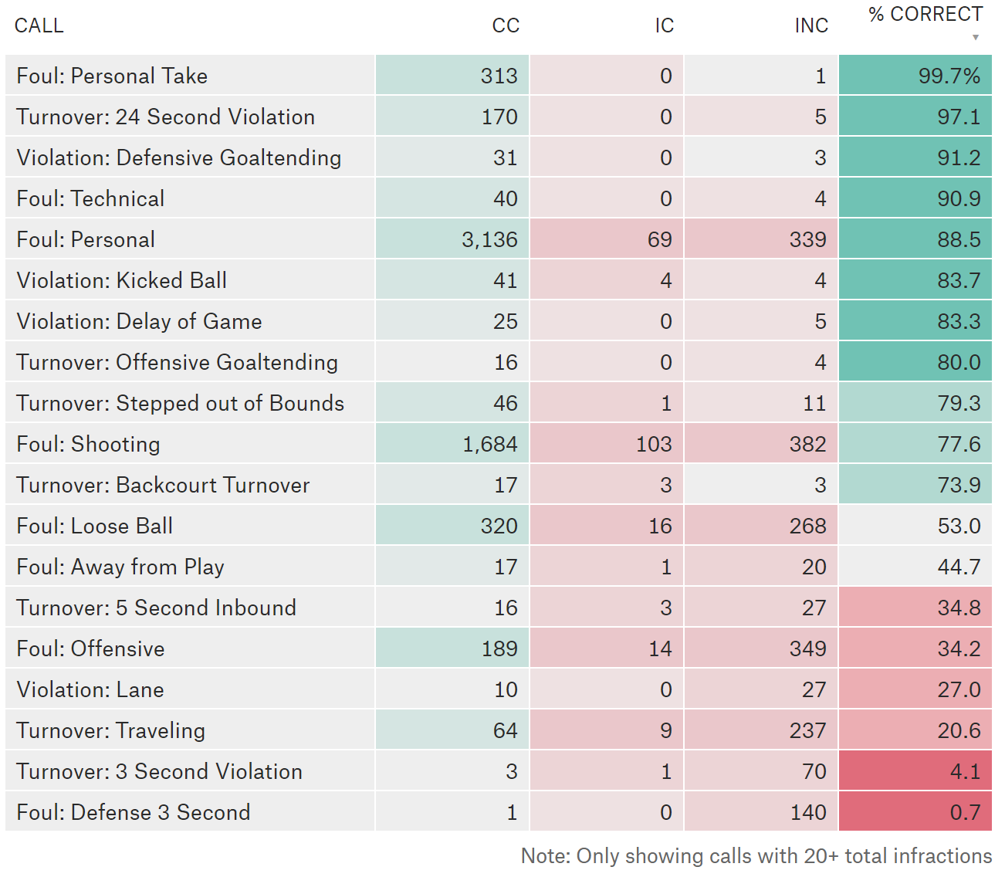

Correctly and Incorrectly awarded fouls in last 2 minutes of closely contested games (Defined as being within 5 points) in the 2017-2018 season.

# Prior Results

* Caudill, Mixon and Wallace (2014) demonstrated star players are awarded a greater amount of free throw attempts during the fourth quarter of NBA Playoff games.
* Price, Remer and Stone (2009) produced evidence that referees favor home teams, teams losing during games, and teams losing in playoff series.
* Deutscher (2015) uses data from the last 2 minutes of closely contested games to conclude, however, that there is no star bias.
* Wolfers and Price (2007) shows that racial bias in refereeing exists in the NBA. However, their results in 2010 show that this bias may have disappeared.

How do I add to the conversation?

* All these reports attempt to examine the situation in final moments of close games. Now, with new NBA PBP (Play-by-play) data, we have access to the whole situation.

# Hypotheses

H1: In the course of regular gameplay, NBA star players are less likely to have a referee pick up on them committing fouls.

H2: In the course of regular gameplay, NBA star players are more likely to draw fouls (have other players foul them).

H3: This bias decreases as we approach later in the game, in more heavily scrutinized scenarios.

H4: Star players are less likely to foul out than non-star players. (considering the situation where players have 5 fouls and are in danger of earning a 6th).

H5: This varies based upon type of foul committed.

# Data

* NBA PBP (Play-by-play) data.
* NBA L2M reports if necessary.

# Analyses to do

H1, H2

Fouls Committed ~ Usage Rate, Minutes played, Positional Fixed Effects,

H3

Same as above, but minutes played

* One way to check if star players are just naturally better than non-star players is by looking at L2M reports. However, is this true for all cases?

H4

Same as above, but filter only in “cusp of” situations

H5

Similar, but evaluating by type of foul.

# References

NBA rules of basketball

Data dictionary

<https://www.kaggle.com/drgilermo/nba-players-stats/activity>

<https://data.world/jgrosz99/nba-player-data-1978-2016/discuss/nba-player-data-1978-2016/gfrdsmrr>